TRICHY DISTRICT ATHLETIC TOURNAMENT ON17.07.18 AT ANNA STADIUM,TRICHY.

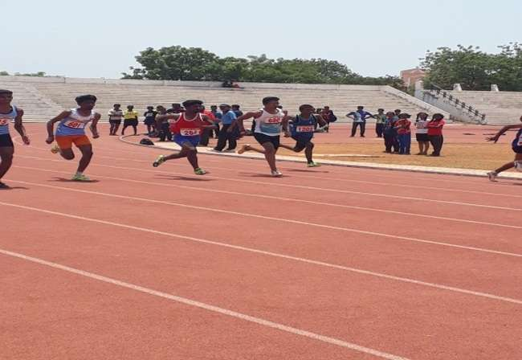

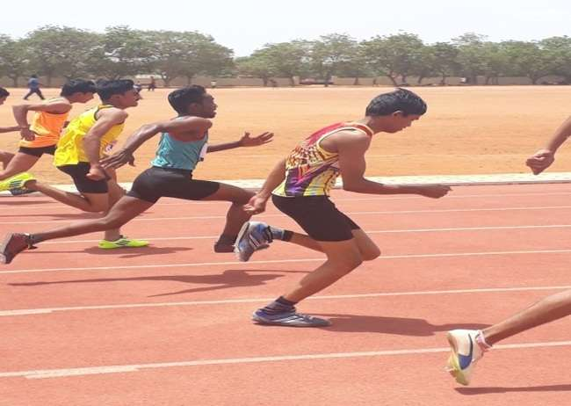

IPAA CRICKET TOURNAMENT ON 31.08.18 AT JAYARAM POLYTECHNIC COLLEGE,THURAIYUR
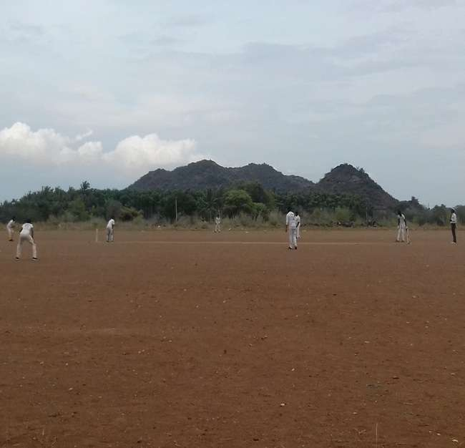

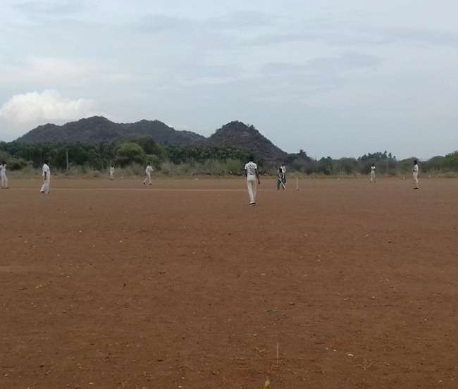

OUR COLLEGE CARROM TEAM WON RUNER PLACE IN IPAA CARROM TOURNAMENT ON 08.09.18 AT RANE POLYTECHNIC COLLEGE,TRICHY.

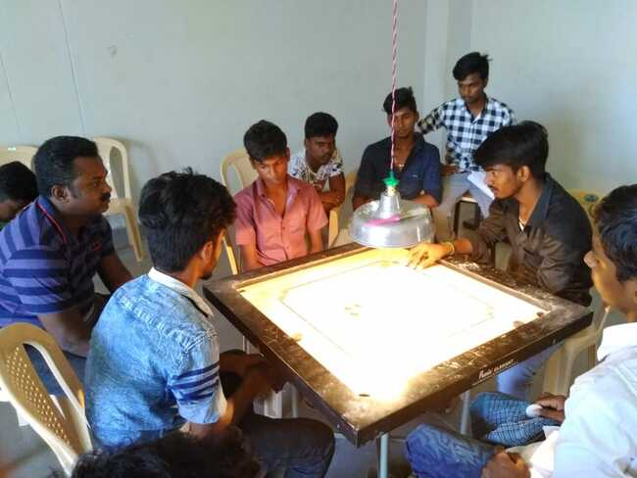

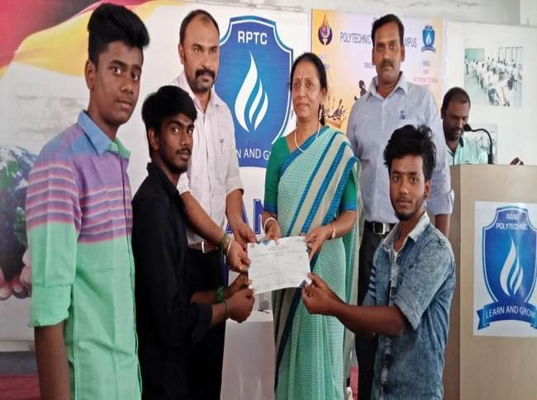

OUR COLLEGE CHESS TEAM WON RUNNER PLACE IN IPAA CHESS TOURNAMENT ON 08.09.18 AT RANE POLYTECHNIC COLLEGE,TRICHY.

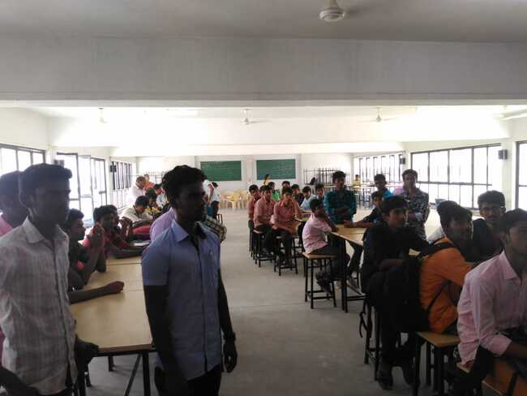

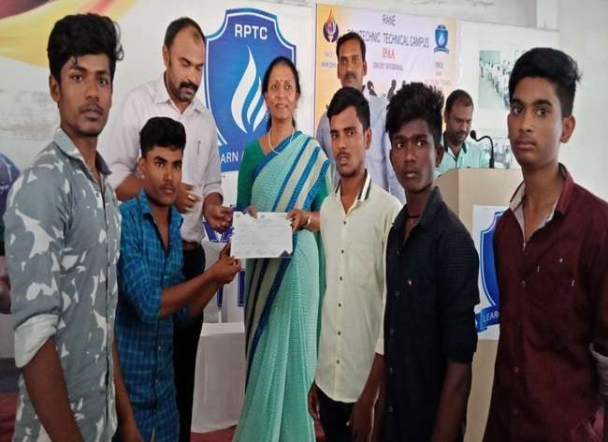

OUR COLLEGE VOLLEY BALL TEAM PARTICIPATE IN IPAA VOLLEY BALL TOURNAMENT ON 14.09.18 AT MAM POLYTECHNIC COLLEGE,TRICHY.
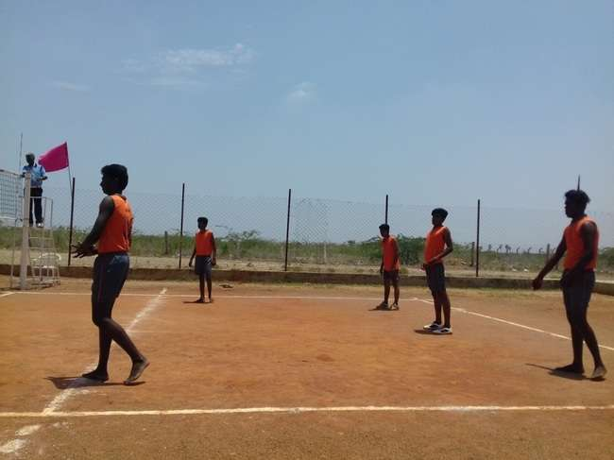

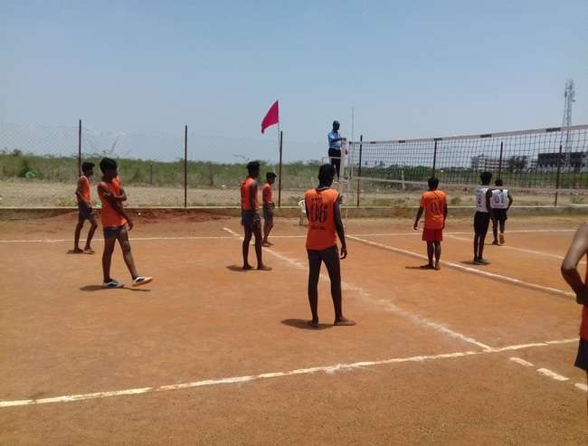

OUR COLLEGE STDENTS ARE PARTICIPATEDCAUVERY HOSPITAL MARATHON RACE ON 30.09.18 AT TRICHY.
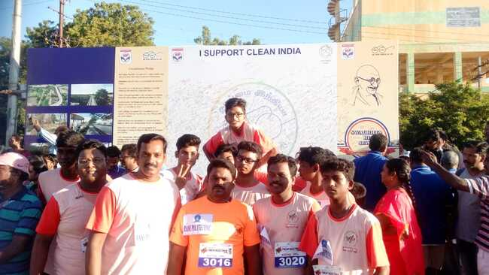

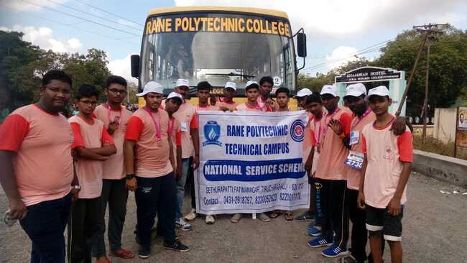

OUR COLLEGE STUDENT T.TAMILSELVAM I DME WON GOLD MEDOLS IN TRICHY DISTRICT SILAMBAM TOURNAMENT ON 23.09.18 AT ANNA STADIUM,TRICHY.

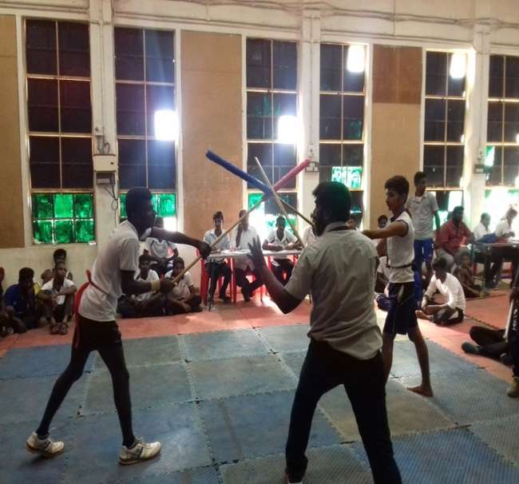

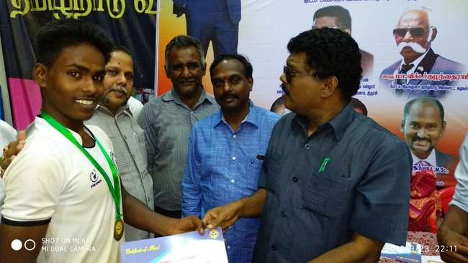

OUR COLLEGE STUDENT T.TAMILSELVAM I DME PARTICIPATED IN STATE LEVEL SILAMBAM TOURNAMENT ON 28.09.18 AT VIDHYALAKSHMI.MATRIC.HIR.SEC.SCHOOL,VELLORE.

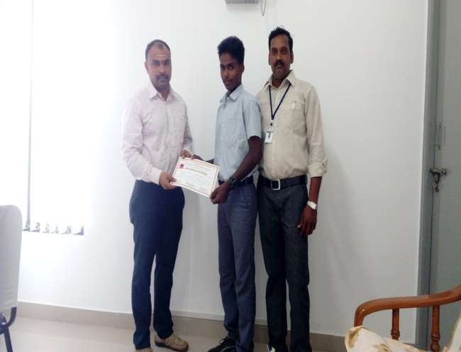

OUR COLLEGE STUDENT T.TAMILSELVAM, DME I WON 1ST PRIZE IN
DISTRICT LEVEL SILAMBAM COMPETITION ON 02.12.2018

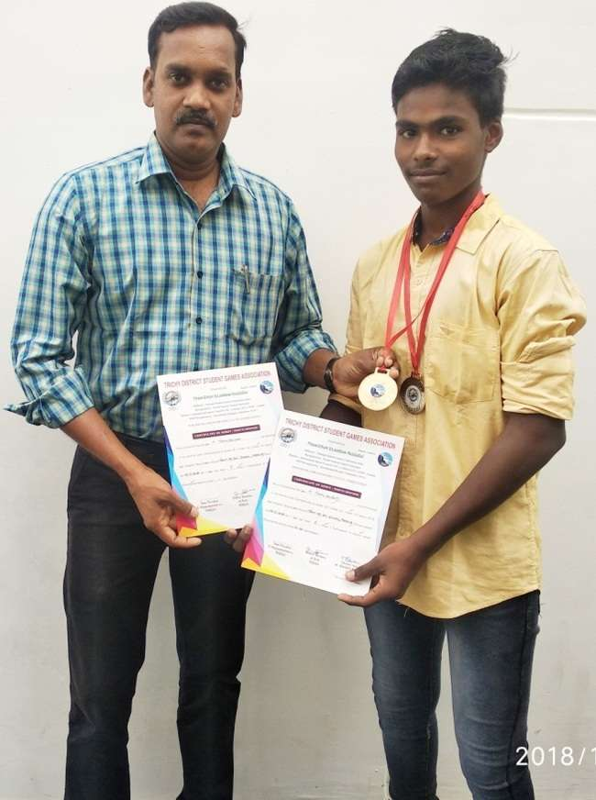

IPAA ATHLETIC TOURNAMENT ON 03.01.19 AT KONGUNADU POLYTECHNIC COLLEGE,THOTTIYAM

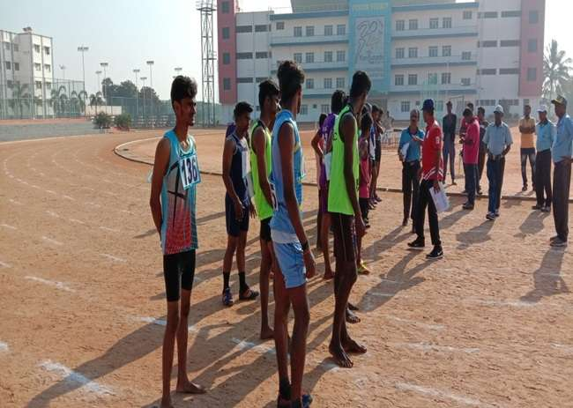

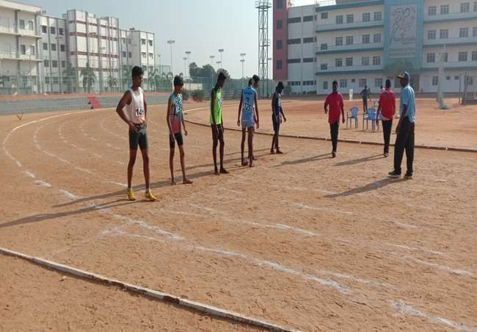

INTER SCHOOL TOURNAMENT ON 06.01.19 AT RPTC.
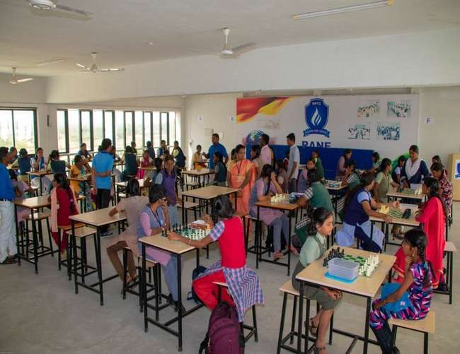
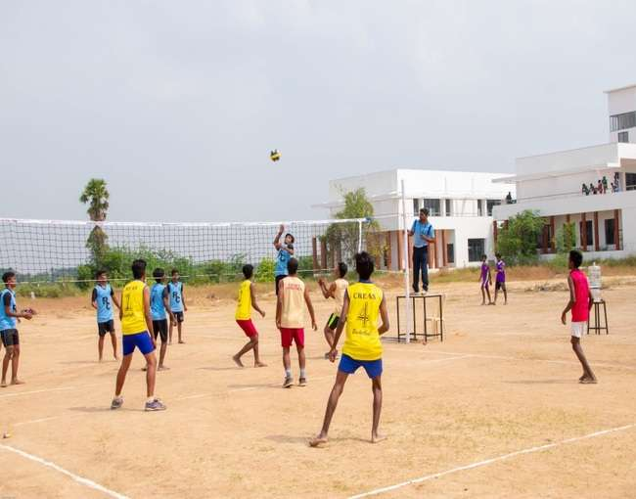
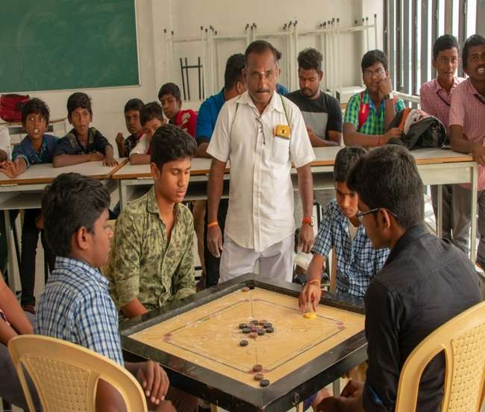
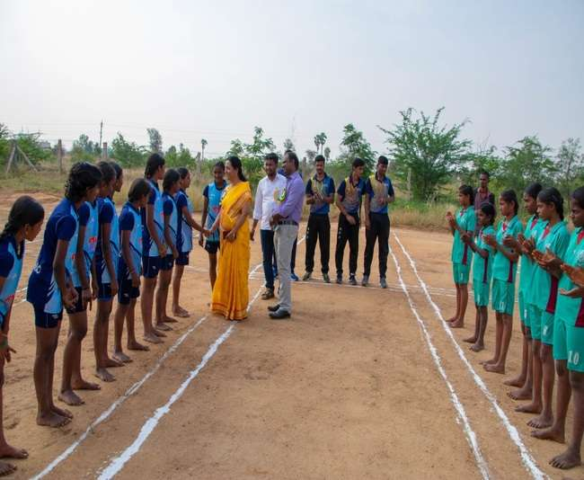

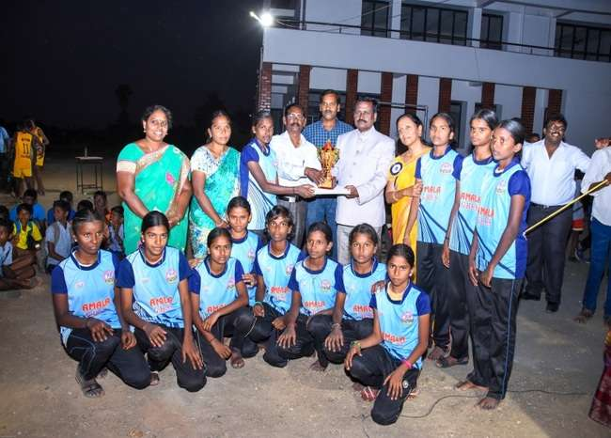
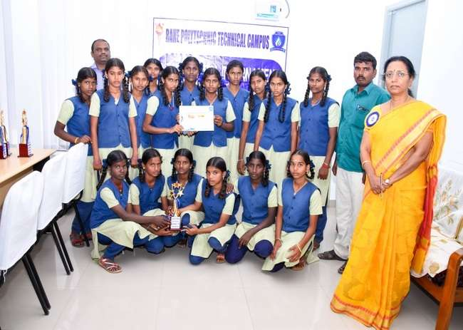
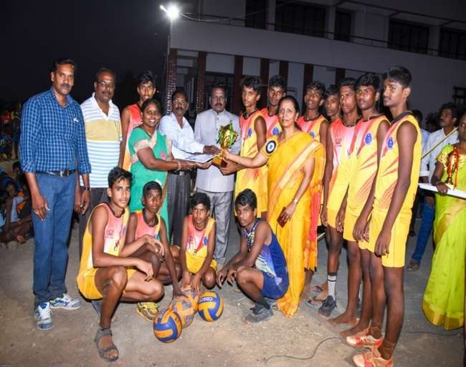
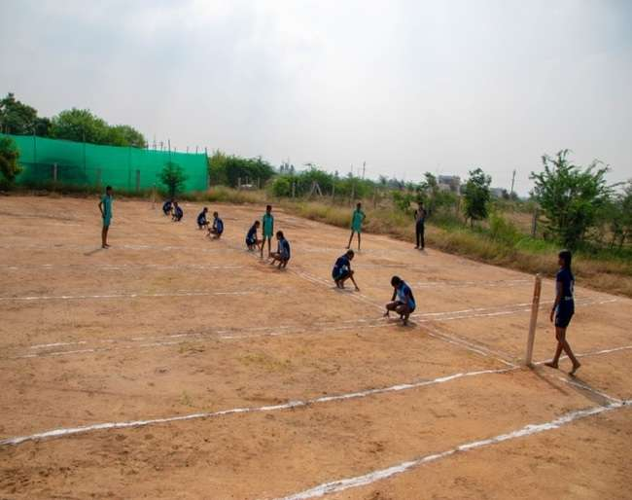
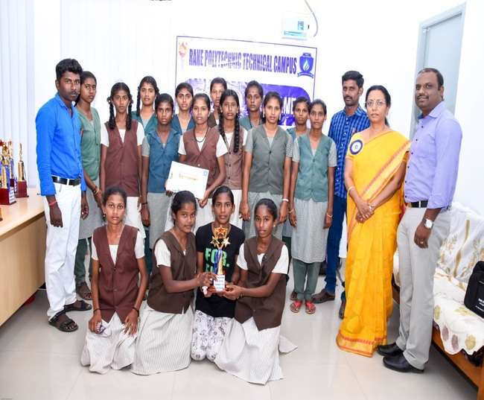
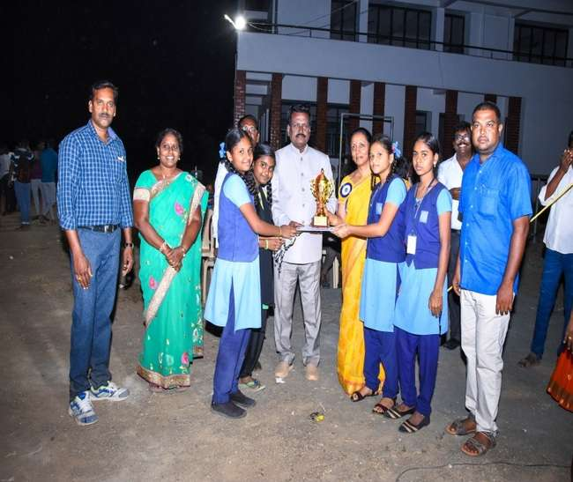
REPUBLIC DAY & SPORTS DAY ON 26.01.19 AT RPTC.

